1. **INTORDUCTION**

* 1. Overview:

Comprehensive analysis, in the financial world, refers to the complete analysis of every relevant aspect of a company's financial operations. The goal of such analysis is to provide a complete picture of the financial status of a company both in the current time and projected into the future. Performing a comprehensive analysis requires gathering all of the information from a company's financial reports, including both the most current report as well as reports from the past. This information is used to calculate financial ratios, which are metrics used to measure different aspects of a company's operations and compare them to similar companies within the same industry.

When investors set out to decide which companies deserve their capital, they often do a rigorous examination of the company's financial information. In this way, they can best decide whether or not a company is a worthy investment. By the same token, the companies themselves may wish to find out how well their numbers stack up to other competitors in the same industry. A comprehensive analysis can achieve these goals by dissecting every aspect of a company's financial data.

One important factor to consider when performing a comprehensive analysis on a company is that the results will only be as accurate as the data which goes into it. This is especially true when attempting to project a company's financial status into some time in the future. Since any future predictions can only be approximations, the data behind those estimates must be extremely precise to prevent incorrect assumptions.

Once all of the data is collected, the next step in a comprehensive analysis is to come up with financial ratios. These ratios generally take one piece of financial information and divide it into another piece to come up with a ratio. Ratios can be used to interpret the strength of practically every important aspect of a company's financial operations, including its [**profitability**](https://www.smartcapitalmind.com/what-is-profitability.htm), liquidity, debt levels, [**cash flow**](https://www.smartcapitalmind.com/what-is-cash-flow.htm), and so on.

These ratios, however, have little importance as simply raw numbers. Knowing, for example, that a company can pay off all its current debt and still have 20 percent of the original amount of its assets intact doesn't mean a whole lot without some context for judging it. That is why one of the final steps of comprehensive analysis should be comparing these ratios to the ratios of other financial leaders within the same industry. Doing this comparison will give an idea of where the company is thriving and what areas need improvement.

1.2 PURPOSE:

Companies use the balance sheet, income statement, and cash flow statement to manage the operations of their business and to provide transparency to their stakeholders. All three statements are interconnected and create different views of a company’s activities and performance.

Balance Sheet

The balance sheet is a report of a company’s financial worth in terms of book value. It is broken into three parts to include a company’s [assets](https://www.investopedia.com/terms/a/asset.asp), [liabilities](https://www.investopedia.com/terms/l/liability.asp), and [shareholder equity](https://www.investopedia.com/terms/s/shareholdersequity.asp). Short-term assets such as cash and accounts receivable can tell a lot about a company’s operational efficiency; liabilities include the company’s expense arrangements and the debt capital it is paying off; and shareholder equity includes details on equity capital investments and retained earnings from periodic net income. The balance sheet must balance assets and liabilities to equal shareholder equity. This figure is considered a company’s [book value](https://www.investopedia.com/articles/investing/110613/market-value-versus-book-value.asp#:~:text=Book%20value%20is%20the%20net,if%20they%20liquidated%20the%20company.) and serves as an important performance metric that increases or decreases with the financial activities of a company.

Income Statement

The income statement breaks down the revenue that a company earns against the expenses involved in its business to provide a bottom line, meaning the net profit or loss. The income statement is broken into three parts that help to analyze business efficiency at three different points. It begins with revenue and the direct costs associated with revenue to identify [gross profit](https://www.investopedia.com/terms/g/grossprofit.asp). It then moves to [operating profit](https://www.investopedia.com/terms/o/operating_profit.asp), which subtracts indirect expenses like marketing costs, general costs, and depreciation. Finally, after deducting interest and taxes, the [net income](https://www.investopedia.com/terms/n/netincome.asp) is reached.

Basic analysis of the income statement usually involves the calculation of gross profit margin, operating profit margin, and net profit margin, which each divide profit by revenue. Profit margin helps to show where company costs are low or high at different points of the operations.

Cash Flow Statement

The cash flow statement provides an overview of the company’s [cash flows](https://www.investopedia.com/terms/c/cashflow.asp) from operating activities, investing activities, and financing activities. Net income is carried over to the cash flow statement, where it is included as the top line item for operating activities. Like its title, investing activities include cash flows involved with firm-wide investments. The financing activities section includes cash flow from both debt and equity financing. The bottom line shows how much cash a company has available.

Free Cash Flow and Other Valuation Statements

Companies and analysts also use free cash flow statements and other valuation statements to analyze the value of a company. Free cash flow statements arrive at a [net present value](https://www.investopedia.com/terms/n/npv.asp) by discounting the free cash flow that a company is estimated to generate over time. Private companies may keep a valuation statement as they progress toward potentially going public.

**Financial Performance**

Financial statements are maintained by companies daily and used internally for business management. In general, both internal and external stakeholders use the same corporate finance methodologies for maintaining business activities and evaluating overall [financial performance](https://www.investopedia.com/terms/f/financialperformance.asp).

When doing comprehensive financial statement analysis, analysts typically use multiple years of data to facilitate horizontal analysis. Each financial statement is also analyzed with vertical analysis to understand how different categories of the statement are influencing results. Finally, ratio analysis can be used to isolate some performance metrics in each statement and bring together data points across statements collectively.Bo

1. **PROBLEM DEFINITION AND DESIGN THINKING**
   1. EMPATHY MAP:

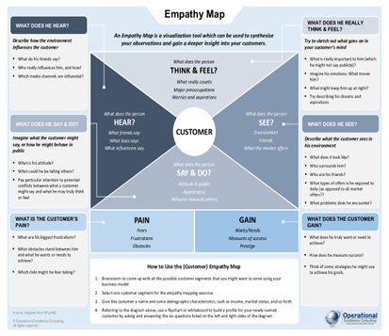

* 1. IDEATION AND BRAINSTORMING MAP:

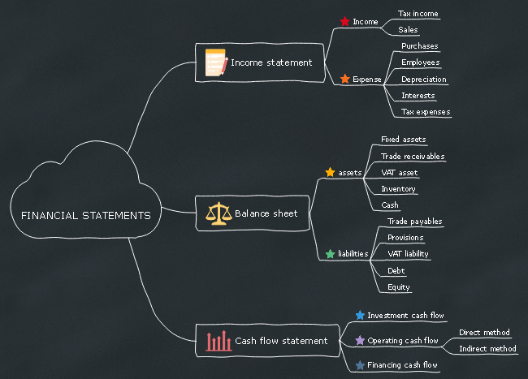

**3.RESULT:**

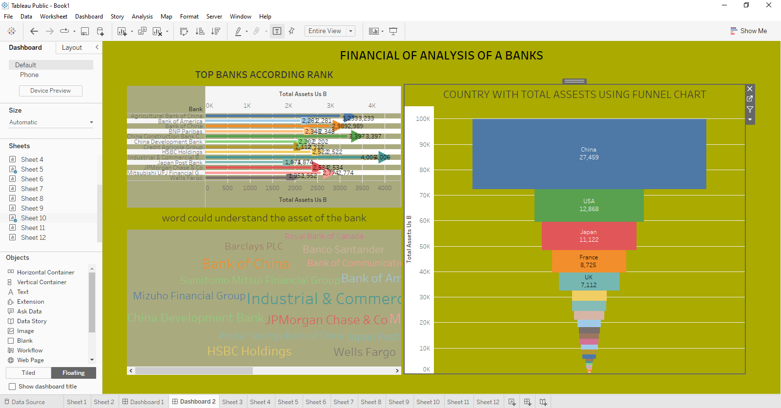

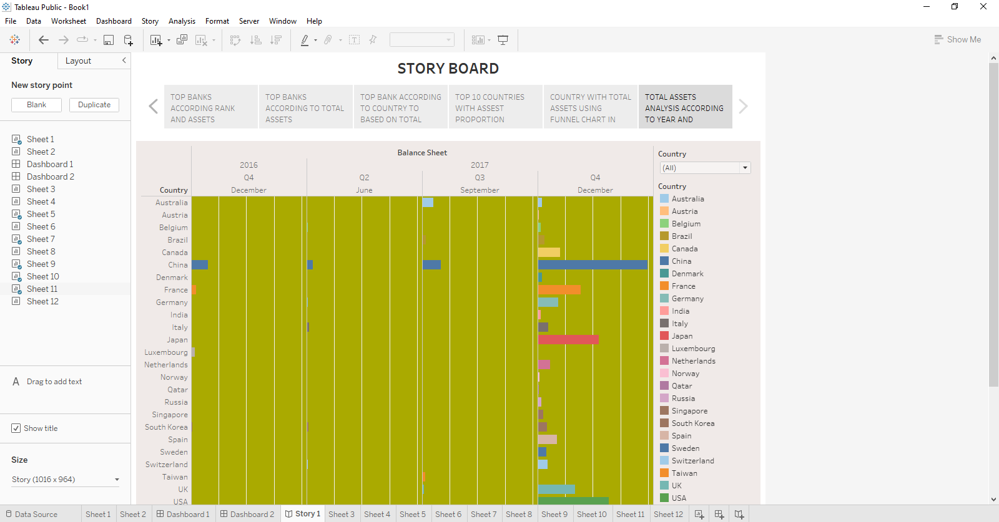

**4.ADVANTAGES AND DISADVANTAGES**

**Advantage:**

The Ability to Detect Patterns

Financial statements reveal how much a company earns per year in sales. The sales may fluctuate, but financial planners should be able to identify a pattern over years of sales figures. For example, the company may have a pattern of increased sales when a new product is released. The sales may drop after a year or so of being on the market. This is beneficial, as it shows potential and sales patterns so executives know to expect a drop in sales.

**Advantage:**

A Chance to Budget Outline

Another advantage of using financial statements for future planning and decision making is that they show the company’s budgets. The budgets reveal how much wiggle room the company has to spend on launching products, developing marketing campaigns or expanding the current office size. Knowing how much money is available for planning and decision making ensures that the company does not spend more than expected.

**Disadvantage:**

Based on Market Patterns

One disadvantage of using financial statements for decision making is that the data and figures are based on the market at that given time. Depending on the market, it may change quickly, so executives should not assume that the numbers from a previous financial statement will remain the same or increase. Just because a company has sold 5 million copies of a product during one year does not guarantee it will sell the same amount or more. It may sell much less if a competitor releases a similar product.

**Disadvantage:**

At-One-Time Analysis

Another disadvantage is that a single financial statement only shows how a company is doing at one single time. The financial statement does not show whether the company is doing better or worse than the year before, for example. If executives decide to use financial statements for making decisions about the future, they should use several financial statements from previous months and years to ensure they get an overall picture of how much the company is doing. The financial statement becomes a continuous analysis, which is more useful than using a single statement.

**5.APPLICATIONS**

Evaluating a company’s historical performance addresses not only what happened but also the causes behind the company’s performance and how the performance reflects the company’s strategy.

The projection of a company’s future net income and cash flow often begins with a top-down sales forecast in which the analyst forecasts industry sales and the company’s market share. By projecting profit margins or expenses and the level of investment in working and fixed capital needed to support projected sales, the analyst can forecast net income and cash flow.

Projections of future performance are needed for discounted cash flow valuation of equity and are often needed in credit analysis to assess a borrower’s ability to repay interest and principal of a debt obligation.

Credit analysis uses financial statement analysis to evaluate credit-relevant factors, including tolerance for leverage, operational stability, and margin stability.

When ratios constructed from financial statement data and market data are used to screen for potential equity investments, fundamental decisions include which metrics to use as screens, how many metrics to include, what values of those metrics to use as cutoff points, and what weighting to give each metric.

Analyst adjustments to a company’s reported financial statements are sometimes necessary (e.g., when comparing companies that use different accounting methods or assumptions). Adjustments can include those related to investments; inventory; property, plant, and equipment; and goodwill.

**6. CONCLUSION**

Analysis of financial statements is extremely important for every business to grow and increase their revenue. It should not be compromised since it increases the efficiency of business operations. Better processes and expert analysts can help in the detailed analysis process.

A financial statement is an accounting document that helps in understanding the financial situation and cash flows in a business. There are different types of statements that serve different purposes.

The analysis of financial statements is a study of the relationship between the financial facts and figures in the financial statements. It estimates the current and past financial positions along with the results of the operation of an enterprise.

It determines the best possible predictions about future conditions. This analysis regroups and analyses information in financial statements to identify the strong and weak points of a business enterprise.

**7.FUTURE SCOPE**

The study is based on the financial position of the firm by using Ratio analysis, Trend analysis and Comparative statements. Financial statements help the management to analyze profit, solvency, liquidity and efficiency etc. this analysis will give the exact picture of the company.

**8.APPENDIX**

<https://www.google.com/search?q=FUTURE+SCOPE+OF+COMPREHENSIVE+ANALYSIS+OF+FINANCIAL+PERFORMANCE&oq=FUTURE+SCOPE+OF+COMPREHENSIVE+ANALYSIS+OF+FINANCIAL+PERFORMANCE&aqs=chrome..69i57.22511j0j15&sourceid=chrome&ie=UTF-8>

<https://acadpubl.eu/jsi/2017-116-13-22/articles/14/31.pdf>

<https://www.google.com/search?q=conclusion+for+financial+statement+analysis&oq=CONCLUSIO&aqs=chrome.2.69i57j0i67i433i650j0i67i650j0i20i263i433i512j0i67i650j0i67i433i650j0i67i650l4.7136j0j15&sourceid=chrome&ie=UTF-8>

<https://www.cfainstitute.org/en/membership/professional-development/refresher-readings/applications-financial-statement-analysis#:~:text=This%20reading%20described%20selected%20applications,screening%20of%20potential%20equity%20investments>.

<https://smallbusiness.chron.com/advantages-disadvantages-financial-statement-analysis-decision-making-21253.html>

